7.2.10 Editors - 3D View - Tool Shelf - Metaball - Edit Mode
Tool Shelf - Metaball - Edit Mode 2
Tweak, Select, 3D Cursor, Transform, Measure and Annotate tools 2
Shear 2
Tool Settings 2
Orientation 2
Last Operator Shear 2
Offset 2
Axis 2
Axis Ortho 2
Orientation 2
Proportional editing 3
Proportional Falloff 3
Proportional Size 3
Connected 3
Projected(2D) 3

Tool Shelf - Metaball - Edit Mode
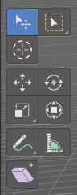

Tweak, Select, 3D Cursor, Transform, Measure and Annotate tools
The Tweak, Select , 3D Cursor, Transform, Measure and Annotate tools at the end of the list are explained in the chapter 7.1.1 Editors - 3D View - Tool Shelf - Object Mode. We won't cover this tools again here.

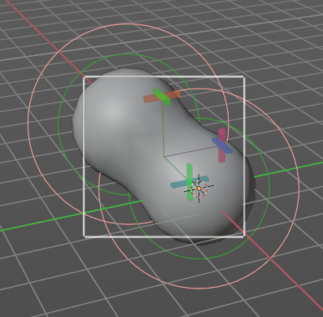
Shear
The shear tool allows you to shear the selected geometry. When you activate the tool, then a widget appears that allows you to pull in the desired direction.
The shear happens between the meta elements. This means you need more than one. And you need to select the meta elements first!

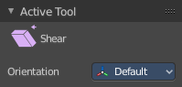
Tool Settings


Orientation
Here you can choose the orientation for the shear action.

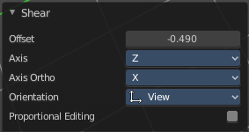
Last Operator Shear

Offset
Here you can adjust an offset.

Axis
Defines one axis of the imaginary shear axis plane.

Axis Ortho
Defines the other axis of the imaginary shear axis plane.

Orientation
Here you can choose the orientation for the shear action.

Proportional editing

Enables proportional editing. Activating proportional editing reveals further settings.

Proportional Falloff
Here you can adjust the falloff methods.

Proportional Size
Here you can see and adjust the falloff radius.

Connected
The proportional falloff gets calculated for connected parts only.

Projected(2D)
The proportional falloff gets calculated in the screen space. Depth doesn't play a role. When it's in the radius, then it gets calculated.

